**Keynote speech（Other new energy and development trends）**

**Other new energy:**

In addition to the solar and wind energy introduced by the above two speakers, the new energy sources currently being developed include water energy, biomass energy, tidal energy, geothermal energy, hydrogen energy, nuclear energy, and combustible ice.

New energy sources have the following characteristics:

1. Renewable and rich in resources

2, Less carbon, less impact on the environment

3, Wide distribution, conducive to small-scale distributed utilization

4, Intermittent supply, large volatility, unfavorable for continuous energy supply

5. Higher development and utilization costs

**Development trends:**

Figure 1: At present, oil and coal are still the world's major sources of power generation. Although new energy accounts for a very small proportion of the global energy consumption structure (the degree of emphasis and policy, the cost of technology is high), in recent years, new energy generation has faster growth.

Figure 2: In 2015, global wind power generation accounted for 3.87% of total power generation, and photovoltaics accounted for 1.34%, which together accounted for only 5.2%, but their growth trend is rapid because wind power and photovoltaics are clean and they have the advantages of environmental protection, as well as the potential for greater cost reduction, and the inexhaustible and healthy energy source for the earth, the future development space is limitless, and will surely become the mainstream of alternative energy in the future.

Figure 3: Now, we can see from the picture that it is at the key node of energy substitution. Energy substitution is accelerating. It is predicted that the global energy structure will change dramatically by 2050, which will greatly improve environmental and energy security issues.

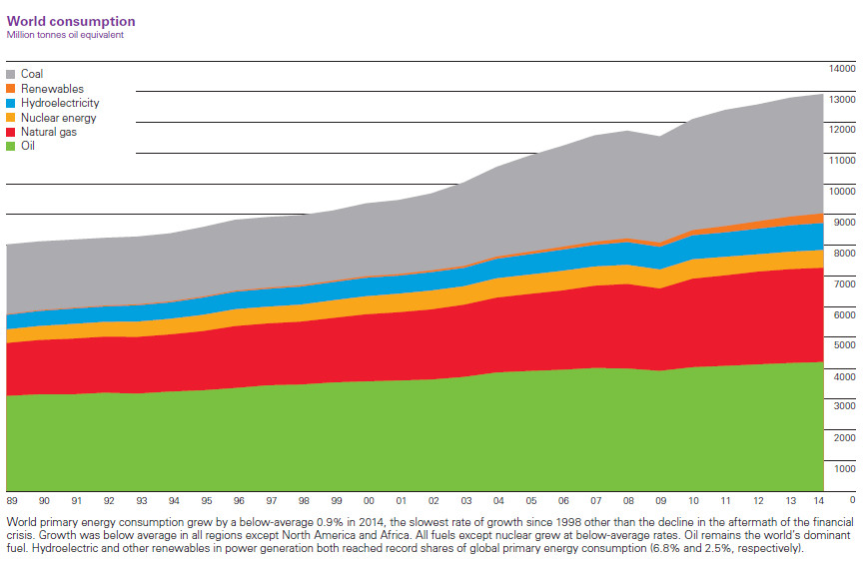

Figure 1.

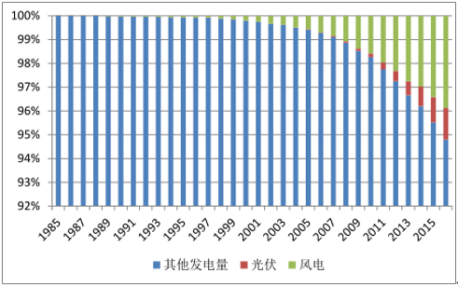

Figure 2.

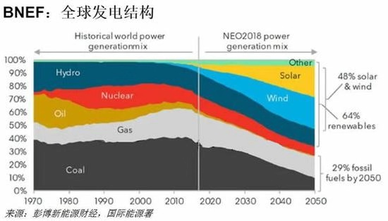

Figure 3.